**Program 2 Report**

1. Problem Statement

The assigned task was to perform 1D filtering operation using MPI on 1, 2, 3 and 4 compute nodes. Providing output of minimum node time, maximum time, and accumulated node time.

1. Approach

I created a .cpp file and a slurm file to read and process the data. The .cpp file open and read the binary file splitting the number of traces amongst the processes. Then out putting the time of the node count using the slurm file setting the node count as 1, 2, 3 and 4.

1. Solution
2. Initialized the dependencies of the program in the .cpp file and slurm file.
3. Defined the d, f and out and zero padded them.
4. Defined Filter
5. Defined Data
6. Open the files filt.bin and data.bin
7. Outputted the time using MPI_Wtime();
8. Mpicc to compile the pgm2.cpp file to pgm2
9. Created the slurm file pgm2.sh
10. Initialized the requirements in the slurm file based off in class discussion.
11. 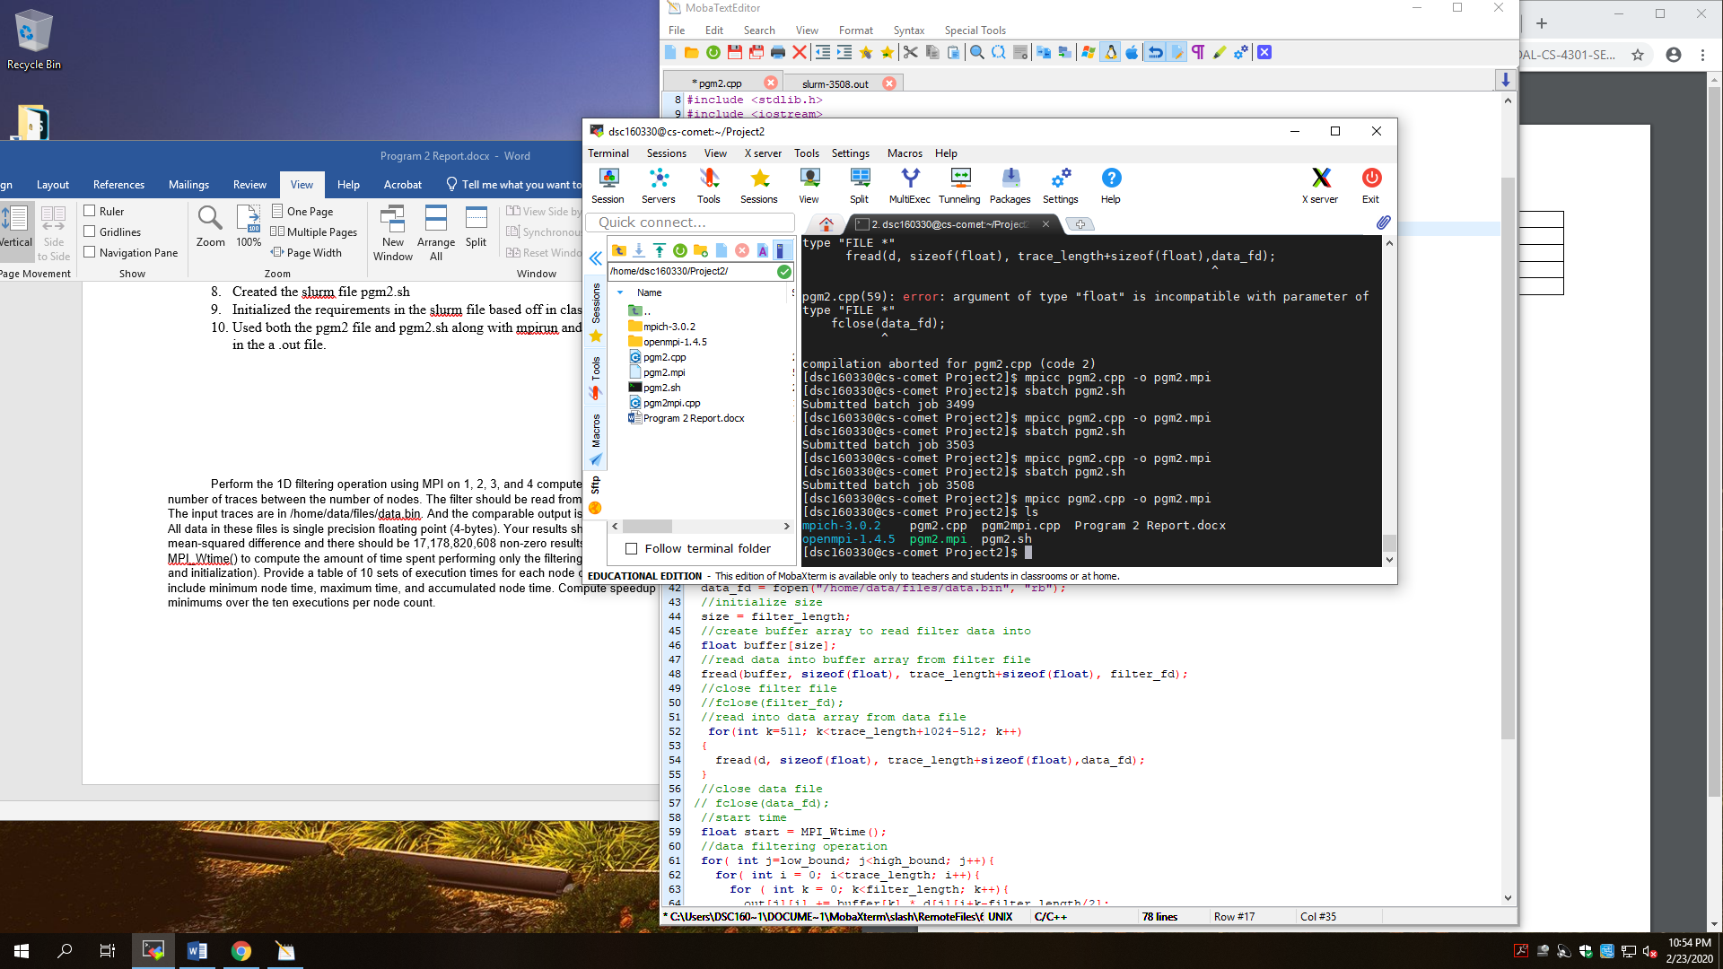Used both the pgm2 file and pgm2.sh along with mpirun and sbatch to get the output in the a .out file of the Wtime(), low bound and high bound.

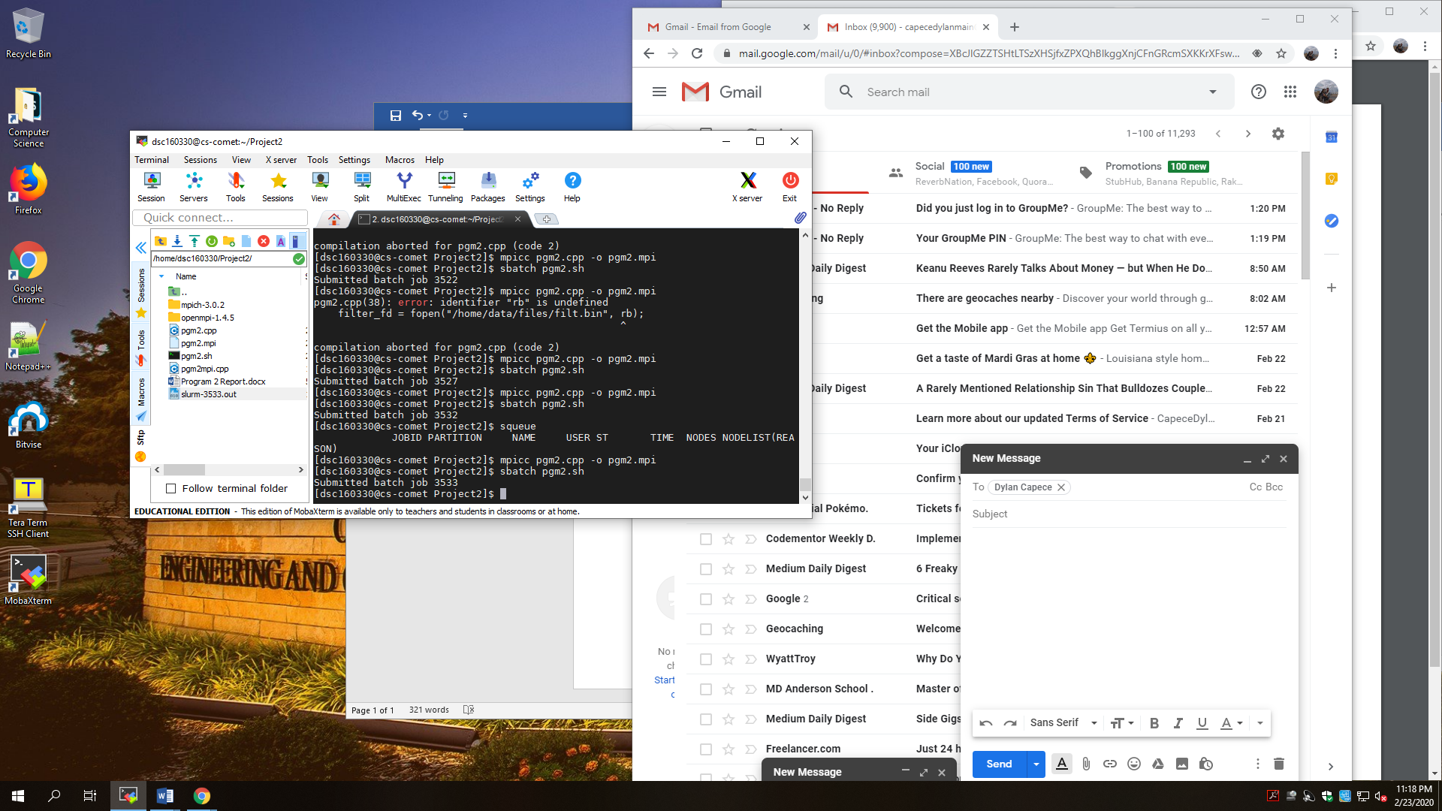

1. Output

Output averages are all roughly zero. The results aren’t perfect but my implementation logic is reasonable. It compiles without errors and it makes me thing I had a much simpler problem that I couldn’t resolve.

